Geometry Viewer Application for BRL-CAD

Mentor: **Christopher Sean Morrison** [brlcad@mac.com](mailto:brlcad@mac.com)

Student: ”**Asad”** Syed Asadullah Hussain [asadullah.hussain@tum.de](mailto:asadullah.hussain@tum.de)

**European Summer of Code 2016**

This document lists down the design for the project. This includes the major milestones and deadlines.

# Outline:

The idea is to build a geometry viewer application that generates a standalone double-clickable file that views a given model. The approach is to concatenate the contents of a given “.g” file with the function calls from librt, libdm that parse and display a “.g” file, in a standard brlcad setup.

Our motivation is to introduce portability and ability to share results of brlcad via email with users who don’t have brlcad setup in their environments. First we will develop a standalone application but later this can be integrated into mged or any other tool as a brlcad feature.

# Task Breakdown:

The brlcad suite has many tools and libraries that interact with each other to render and view models. The general architecture is given below:

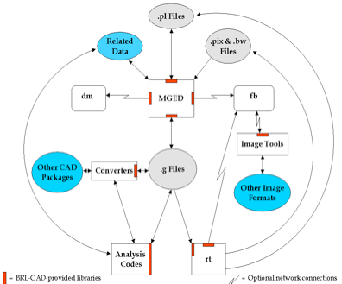

The most important part for us out of this architecture is the geometry rendering libraries, to be more specific **librt** & libdm.

* [Librt](http://brlcad.sourceforge.net/doxygen/da/d12/group__librt.html), the library that contains all of the geometry support. It parses the “.g” file and its function calls can be used to extract contents of “g” file. We will use this to parse our model file for Libdm. The relevant function call is “db_open”. There is also possibility to use a higher level library “libged” (ged_open)
* [Libdm](http://brlcad.org/docs/doxygen-r64112/d4/de4/group__libdm.xhtml) is BRL-CAD's primary graphics display manager (dm) library. It is used to display geometry in GUI. This will be utilized by our source to visualize model files.

# This resulting draw result will then be bundled into an “.exe” (windows) and later into packages for Mac & Linux.

# Task list:

1. Evaluate technology to be used
   1. Develop initial project design draft
   2. Setup development environment
   3. Evaluate programming language choice (C decided, for GUI may use some Python)
2. Evaluate and look into current viewer applications:
   1. Mged / archer
   2. Isst, it doesn’t use libdm.
   3. Geometry viewer (<https://github.com/BRL-CAD/geometry_viewer>)
3. **Create application interface to brlcad libraries (**[**http://brlcad.org/w/images/3/3d/Application_Development.pdf**](http://brlcad.org/w/images/3/3d/Application_Development.pdf)**)**
   1. Interface with librt
   2. Interface with libdm
4. **Create application interface with model file:**
   1. Create input interface to parse “.g” file
   2. Create output interface to parse output from libdm.
5. **Develop front end**
   1. Develop Single window view
   2. Develop File Input
6. Write Functional testing test cases.

# Project Workflow:

* This design document will be updated regularly to include the status of tasks as well as any changes in project scope and/or approach.
* The source will be upload on: <https://github.com/asadpiz/brlcad-viewer>
* There will also be occasional weekly status meetings on irc #brlcad (Fridays 16:00 GMT+2)

# References:

<http://brlcad.org/w/images/3/3d/Application_Development.pdf>

<http://brlcad.sourceforge.net/doxygen/modules.html>

<http://brlcad.org/docs/doxygen-r64112/index.xhtml>